Tilt switch

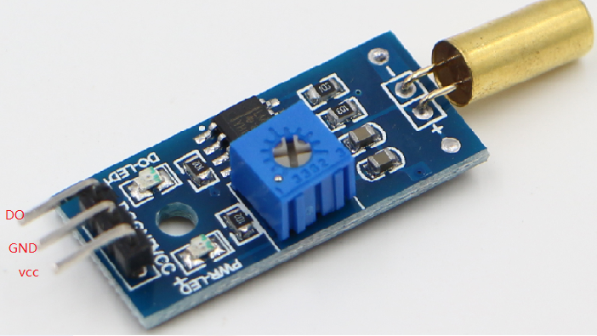

Tilt switch module arduinocontroller

DO 3

GND GND

VCC VCC